**World Quant University**

**Professor: Harry Wang**

**Algorithms II**

Nikolas Lippmann Pareschi - [nikolaslippmann@gmail.com](mailto:nikolaslippmann@gmail.com)

**Assignment 6: Formulating Problems as Linear Programs**

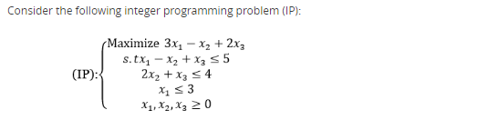

### Problem 1:

Write the LP relaxation (P1) of (IP) and explain why the objective value of an optimal solution to (P1) is an upper bound on the value of an optimal solution to (IP).

Use Python for the implementation for your Algorithm.  Adhere to the code guidelines mentioned below.

First we write the Integer Programming Problem (IP) and compute the results:

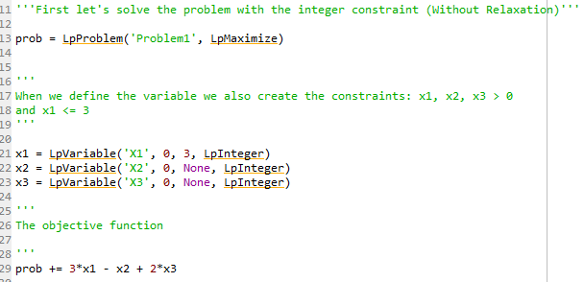

We have defined the contraints: x1, x2, x3 > 0 in the variable definition. Also we have defined that x3 <= 3. We have defined too the objective function. Next we define the other constraints:

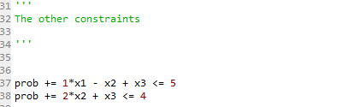

Then we solve the problem:

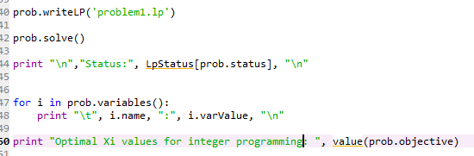

Results:

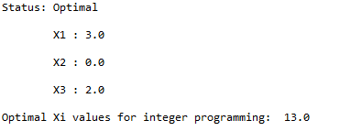

Next we implement the same problem but with the relaxation, admitting the continuous case:

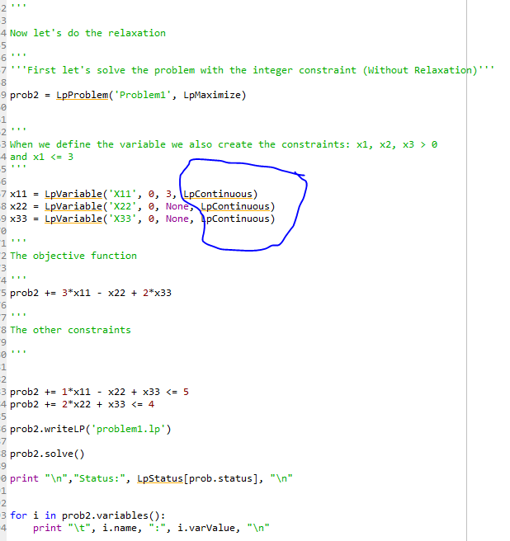

Results:

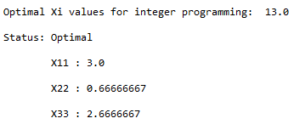

As one can observe X11, X22 and X33 are upper bounds of X1, X2 and X3. X1 and X11 have the same value, X2 is 0 and X22 is 0.666 and X3 is 2 while X33 is 2.6666.

This happens because any Integer Problem may be viewed as the Linear Program relaxation plus additional constraints. This means that the feasible region for any IP must be contained in the feasible region for the corresponding LP relaxation. [1] In other words, since the Linear Program relaxation is less constrained than the Integer Problem, it is immediate that if Integer Problem is a maximization, the optimal objective value for the linear problem relaxed is greater than or equal to that of the Integer Problem.

Regarding financial applications and alpha generation, linear problems can solve for example the necessity of hedge funds to maximize the capital invested without buying fractional lots, which have less liquidity. Also, we see some academic papers that used linear programming to alpha generation [2]:

***Abstract***

*This is a classic study, by the “Old Masters”, of the method-centered approach to management problems. It demonstrates once again the extraordinary power of the linear-programming framework, in dealing with complex business-decision problems. Students of the capital-budgeting process will find it filled with insights, and highly suggestive. It may eventually become the established basis for a revised conception of the interaction between financial planning and the economic analysis of engineering projects.*

[1] World Quant University class notes, Algorithms II, pages 176 and 202

[2] <https://www.tandfonline.com/doi/abs/10.1080/001379X6008546907?journalCode=utee20>